


Design Thinking Methodology

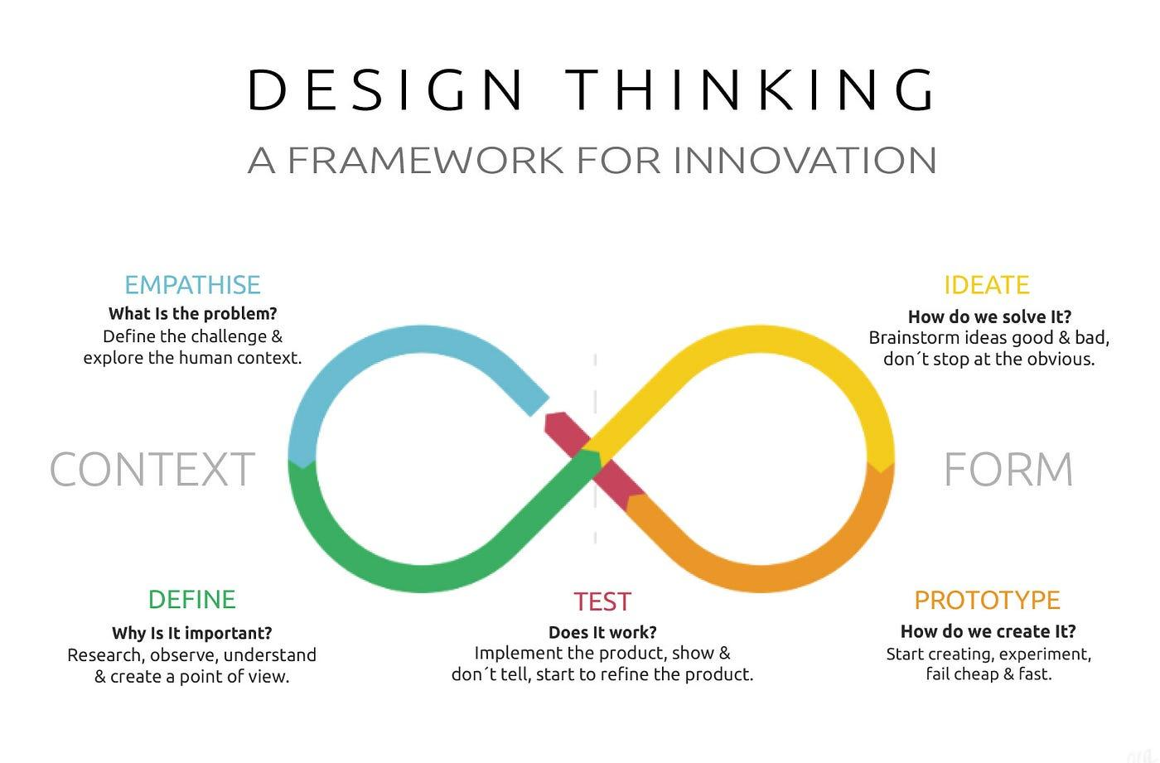

Design Thinking is a human-centred problem-solving approach that emphasizes empathy, ideation, and prototyping to address complex challenges. It places the end-user at the core of the design process, fostering innovative solutions that meet real needs.
As an iterative process, these steps may be revisited and repeated as necessary to continually enhance and optimize the final solution. It encourages a dynamic, user-centric, and collaborative approach to problem-solving.

5 Steps of Design Thinking
Empathize
Objective: Understand the user's needs, feelings, and challenges.
Activities: Conduct interviews, surveys, and observations to gain insights into the user's perspective.
Outcome: Empathy maps, user personas, and a deep understanding of user experiences.

Define
Objective: Clearly articulate the problem based on user insights.
Activities: Analyse collected data, identify patterns, and frame the problem statement.
Outcome: A well-defined problem statement that guides the ideation phase.

Ideate
Objective: Generate a multitude of creative solutions to the defined problem.
Activities: Conduct brainstorming sessions, encourage diverse thinking, and explore unconventional ideas.
Outcome: Numerous ideas, concepts, or potential solutions for the identified problem.

Prototype
Objective: Create a tangible representation of selected ideas for testing and refinement.
Activities: Build low-fidelity prototypes, mock-ups, or simulations of potential solutions.
Outcome: Physical or digital prototypes that allow for iterative testing and improvement.

Test
Objective: Collect feedback and refine solutions based on user testing.
Activities: Engage users in testing prototypes, gather feedback, and observe interactions.
Outcome: Insights into the viability and desirability of proposed solutions, leading to further refinement.

